PLAYER & TEAM OFFICIAL
ACCREDITATION FORM

Please complete and return this form to informacionpublica@badminton.com.gt , gt.tecnica2023@gmail.com , tecnicabadguate@gmail.com, mierjoseduardo@gmail.com not later than
August 19, 2024 Please fill up the form and send Photo as per requirement. Please take note that we will not accept Selfie Photo. Please refer to Photo sample below.

This accreditation form is for Athletes, Coaches, Physiotherapists, Doctors and technical delegates.

Please type clearly in CAPITAL LETTERS.

Name of Member Association:
Contact Person:
MOBILE NUMBER: |  | PHONE NUMBER:
E-MAIL:

No. | FULL NAME | Official Position  (Player, Coach, Physiotherapist, Nutritionist, Masseur, etc.)
1
2
3
4
5
6
7
8
9
10
11
12
13
14
15

SAMPLE :
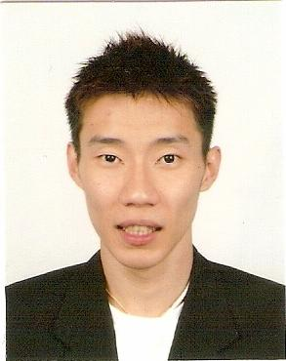
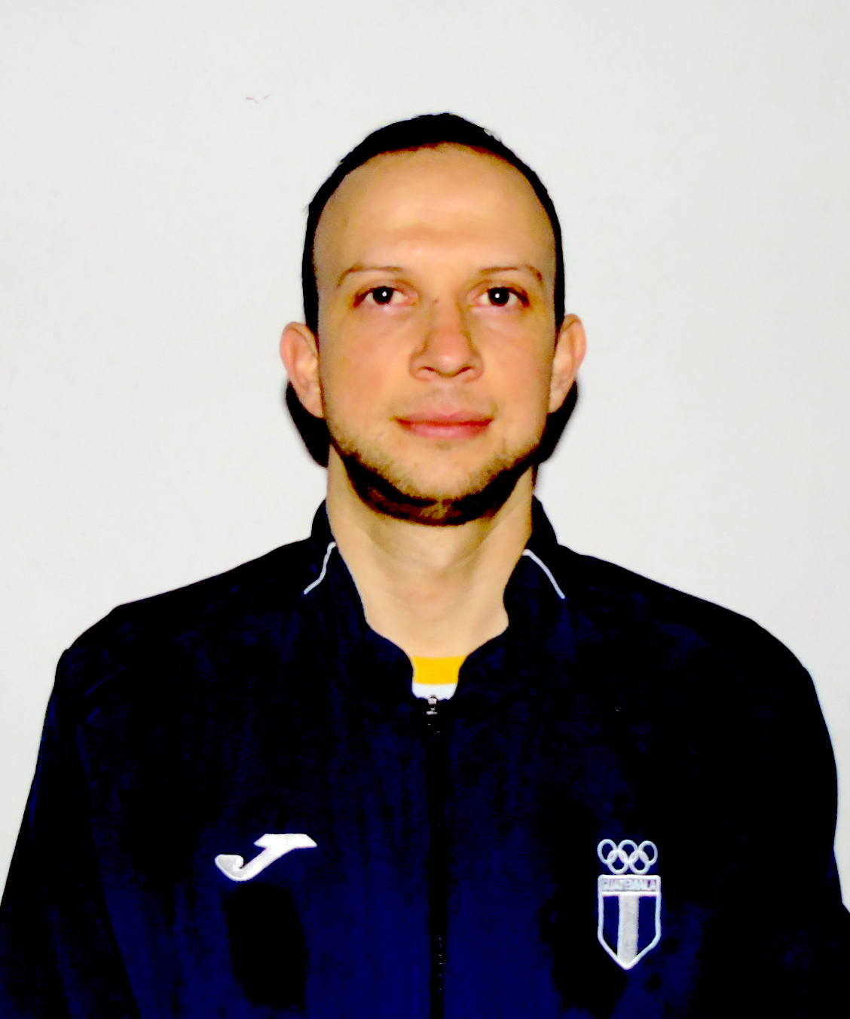

LEE CHONG WEI
MALAYSIA

NAME
COUNTRY

Kevin Cordón
Guatemala
NAME
COUNTRY

NAME
COUNTRY
NAME
COUNTRY
NAME
COUNTRY
NAME
COUNTRY
NAME
COUNTRY
NAME
COUNTRY
NAME
COUNTRY
NAME
COUNTRY
NAME
COUNTRY
NAME
COUNTRY
NAME
COUNTRY
NAME
COUNTRY

NAME
COUNTRY
NAME
COUNTRY
NAME
COUNTRY
NAME
COUNTRY
NAME
COUNTRY
NAME
COUNTRY
NAME
COUNTRY
NAME
COUNTRY
NAME
COUNTRY
NAME
COUNTRY
NAME
COUNTRY
NAME
COUNTRY

