

**COPA REGATAS INTERNATIONAL JUNIOR MULTI-CATEGORY 2024**

**PLAYER & TEAM OFFICIAL ACCREDITATION FORM**

Please complete and return this form to [**comisionbadcrl@yahoo.com**](mailto:comisionbadcrl@yahoo.com) not later than **October 8, 2024. Please fill up the form and send the photos as per requirement. Please take note that we will not accept selfie photos. Please refer to photo sample below.**

Please type clearly in **CAPITAL LETTERS**.

|  |  |
| --- | --- |
| **Name of Member Association:** |  |
| **Contact Person:** |  |
| **Mobile Number:** |  |
| **e-mail:** |  |

**COACH(ES) AND TECHNICAL STAFF**

|  |  |  |
| --- | --- | --- |
| **No.** | **FULL NAME** | **Official Position**  (Player, Coach, Physiotherapist, Nutritionist, Masseur, etc.) |
| 1 |  |  |
| 2 |  |  |
| 3 |  |  |
| 4 |  |  |

**PLAYER(S)**

|  |  |  |
| --- | --- | --- |
| 5 |  | PLAYER |
| 6 |  | PLAYER |
| 7 |  | PLAYER |
| 8 |  | PLAYER |
| 9 |  | PLAYER |
| 10 |  | PLAYER |
| 11 |  | PLAYER |
| 12 |  | PLAYER |
| 13 |  | PLAYER |
| 14 |  | PLAYER |
| 15 |  | PLAYER |
| 16 |  | PLAYER |
| 17 |  | PLAYER |
| 18 |  | PLAYER |
| 19 |  | PLAYER |
| 20 |  | PLAYER |
| 21 |  | PLAYER |
| 22 |  | PLAYER |
| 23 |  | PLAYER |
| 24 |  | PLAYER |
| 25 |  | PLAYER |
| 26 |  | PLAYER |
| 27 |  | PLAYER |

**PLAYERS:**

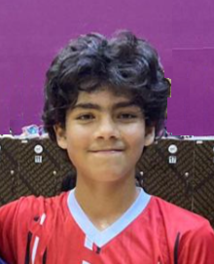

**Umesh Lescano**

**PERU**

**NAME**

**COUNTRY**

**NAME**

**COUNTRY**

**NAME**

**COUNTRY**

**NAME**

**COUNTRY**

**NAME**

**COUNTRY**

**NAME**

**COUNTRY**

**NAME**

**COUNTRY**

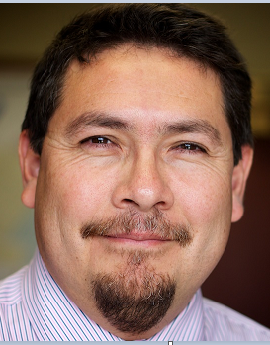 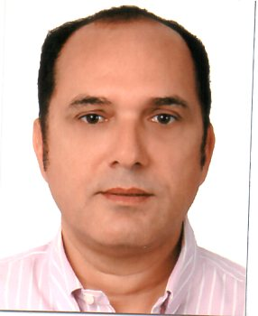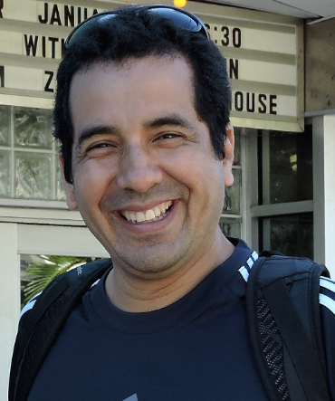

**NAME**

**COUNTRY**

**NAME**

**COUNTRY**

**NAME**

**COUNTRY**

**NAME**

**COUNTRY**

**Manuel Buendía**

**PERU**

**Andrés Lescano**

**PERU**

**Alberto Munar**

**PERU**

**NAME**

**COUNTRY**

**NAME**

**COUNTRY**

**NAME**

**COUNTRY**

**NAME**

**COUNTRY**

**NAME**

**COUNTRY**

**NAME**

**COUNTRY**

**NAME**

**COUNTRY**

**NAME**

**COUNTRY**

 

**NAME**

**COUNTRY**

**NAME**

**COUNTRY**

**NAME**

**COUNTRY**

**NAME**

**COUNTRY**

**Manuel Buendía**

**PERU**

**Andrés Lescano**

**PERU**

**Alberto Munar**

**PERU**

**COACHES AND OTHER TECHNICAL STAFF:**

**NAME**

**COUNTRY**

**NAME**

**COUNTRY**

**NAME**

**COUNTRY**

**NAME**

**COUNTRY**

**NAME**

**COUNTRY**

**NAME**

**COUNTRY**

**NAME**

**COUNTRY**

**NAME**

**COUNTRY**

**NAME**

**COUNTRY**

**NAME**

**COUNTRY**

**NAME**

**COUNTRY**

**NAME**

**COUNTRY**